Ulrike Wolf - Flautist
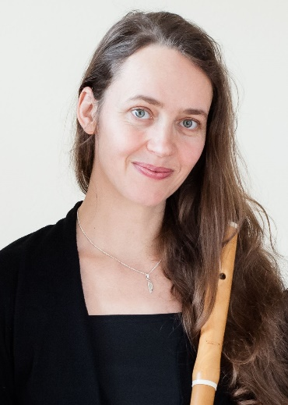
Ulrike Wolf was born in Bautzen, Germany, and studied flute and traverso at the academies of music in Dresden and in Leipzig (Irmela Boßler, Benedek Csalog).
Subsequent studies in Lyon and a master course in Brussels at the Koninklijk Conservatorium with Barthold Kuijken and Bart Coen led her to specialize in the historic practice performance of early music (traverso, recorder).

In June 2001 she was the winner of the International Handel Competition for Traverse Flute in Halle and in 2002 she won the Competition for Early Music at the museum for musical instruments, Berlin.

She performs on a regular basis with various renowned orchestras, such as “La Petite Bande”, “European Union Baroque Orchestra”, “Leipziger Barockorchester” and “Leipziger Concert”. She is also founding member and soloist in several ensembles for chamber music such as the trio “Flautissimo Leipzig”.

After completing her post-graduate studies in Elementary Music Education at the Academy of Music Leipzig in 2010, Ulrike Wolf is also teaching flute and chamber music at various music schools.

